Menu |  | - Whole 30 Week 3
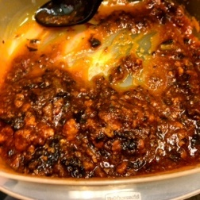  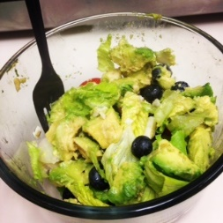 |  | Sunday  Breakfast: Spinach-stuffed sweet potatoes with over-easy eggs  Lunch: Salad with chicken  Dinner: Tuna steak with roasted vegetables  Monday  Breakfast: Fruit and 2 eggs over easy  Lunch: Salad with chicken  Dinner: Veggie Chili  Tuesday  Breakfast: 2 soft-boiled eggs and fruit  Lunch: Leftover chili  Dinner: Chicken thighs with baked potatoes and veggies  Wednesday  Breakfast: Spinach-stuffed sweet potatoes with over-easy eggs  Lunch: Salad  Dinner: Tuna-stuffed avocado and tomato  Thursday  Breakfast: Kale and mushroom omelet  Lunch: Tuna stuffed avocado and tomato  Dinner: Pork chops with baked potato and veggies  Friday  Breakfast: Spinach-stuffed sweet potatoes with over-easy eggs  Lunch: Salad with chicken  Dinner: Slow-cooker chicken and gravy with potatoes and brussels spouts  Saturday  Breakfast: 2 soft-boiled eggs and fruit  Lunch: Leftover Slow-cooker chicken and gravy with veggies  Dinner: Steaks and baked sweet potato fries with veggies

